Fossil-Scorpion in amber

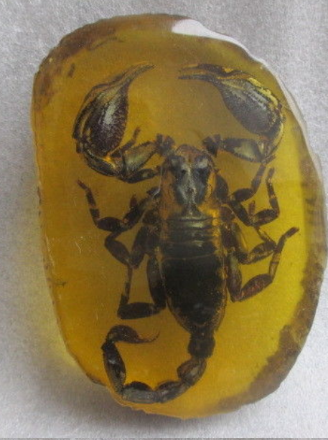 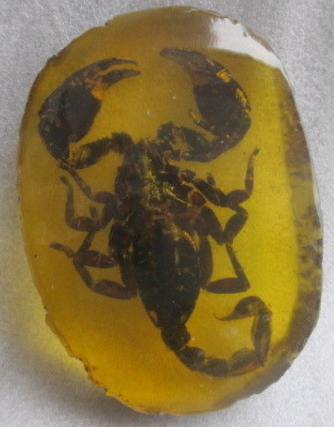

11 cm \* / 4.33 inches

7.6 cm \* / 3.  inches

1.8 cm \* / 0.7 inches

 Weight: 130 grams / 0.28 pounds

